

**CHUALAR 4-H**

**ROLLER SKATING PARTY**

**FRIDAY, APRIL 7TH**

**6:30 PM – 8:30 PM**

**WATER CITY SKATE**

2801 2nd Ave, Marina

**[**



Bring a new Teddy Bear

**Teddy Bears for Hearts- As a community service project; we will be collecting new teddy bears for the Monterey County Sheriff Department.**

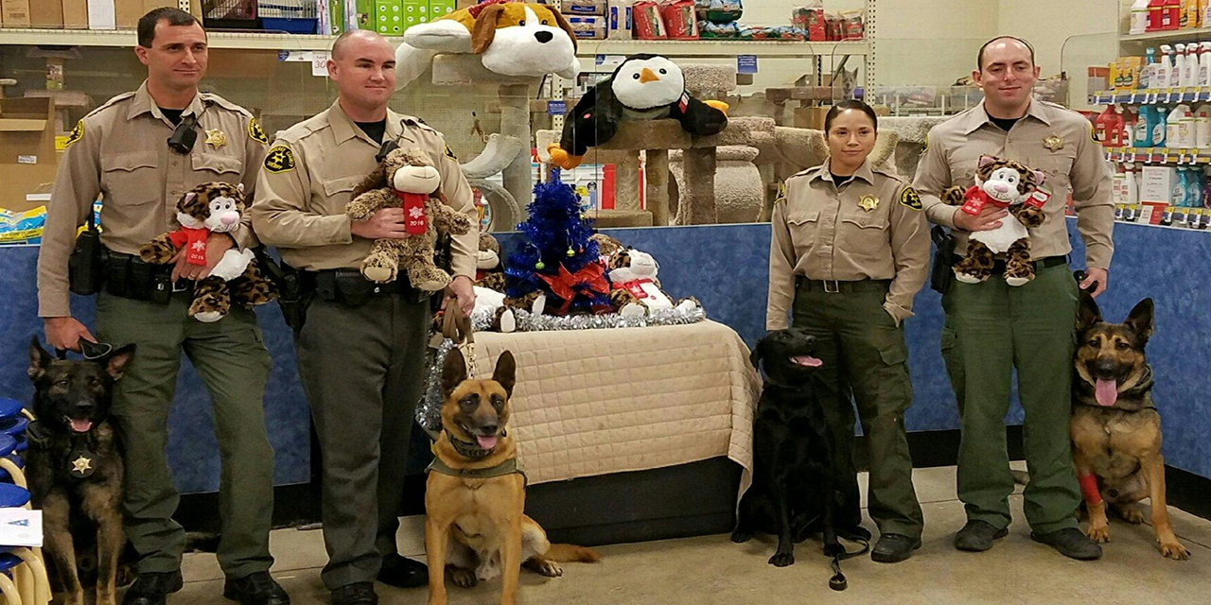

Includes skate rentals, skating, pizza, dessert, & beverage

Cost: $4 per 4-H member & non-skaters

$10 for parents and Non 4-H siblings

4-Hers don’t forget your medical release forms.

Please RSVP to [tracy24246@aol.com](mailto:tracy24246@aol.com)

[DenaJenkinson@sbcglobal.net](mailto:DenaJenkinson@sbcglobal.net)

Or update via invitd app

*It is the policy of the University of California (UC) and the UC Division of Agriculture & Natural Resources not to engage in discrimination against or harassment of any person in any of its programs or activities (Complete nondiscrimination policy statement can be found at*[*http://ucanr.edu/sites/anrstaff/files/169224.pdf*](http://ucanr.edu/sites/anrstaff/files/169224.pdf)*) Inquiries regarding ANR’s nondiscrimination policies may be directed to Linda Marie Manton, Affirmative Action Contact, University of California, Davis, Agriculture and Natural Resources, 2801 Second Street, Davis, CA 95618, (530) 750-1318.*